Quadrature Amplitude Modulation

David B. and Mohamed A.

Dec 12, 2014

Contents:

1. Introduction
   1. Purpose
   2. Scope
   3. Definitions and Acronyms
2. System Overview
3. System Architecture
   1. Architectural Design
   2. Design Rationale
4. Human Interface Design
   1. Overview off User Interface
5. Introduction
   1. Purpose

This design document describes the system design of a Quadrature Amplitude Modulation (QAM) radio transmitter.

* 1. Scope

This project aims to establish analog communication between two computers over generic radio band or single wire, utilizing quadrature amplitude modulation, with the goal of transmitting two separate analog signals over the same transmission line, and recovering them accurately.

* 1. Acronyms

QAM: Quadrature Amplitude Modulation  
MODEM: MOduation-DEModulation

SDR: Software Defined Radio

LV: LabView 2014 32-bit

FFT: Fast Fourier Transform

1. System Overview

This project has three relatively separate components, two software MODEMs utilizing LV for analog and digital signals, and a radio transmitter and receiver in hardware, to explore the use of SDRs in communications. Although the same general modulation methods are used for both digital and analog QAM, their implementations are very different. For both we start off with an input signal, a binary string for digital and a complex waveform (essentially consisting of two separate waves, like for stereo audio) for analog. This signal to be modulated is split bitwise (the bits of the binary string are alternatingly assigned to the two modulation paths) for digital, or by separating the signal into real or imaginary components for analog. However, we get into the heart of QAM, the carrier wave that serves as the envelope for sending the signals is in fact two with one being 90 degrees out of phase in comparison to the other, this is referred to as being in quadrature. This creates a cosine term, and a sine term with which the now separated signals will be ‘mixed’ with, practically speaking multiplied by as in normal amplitude modulation, and the two modulated signals will be combined to form a composite waveform that is to be transmitted. (An ideal transmitter diagram is shown below, sourced from Wikipedia)

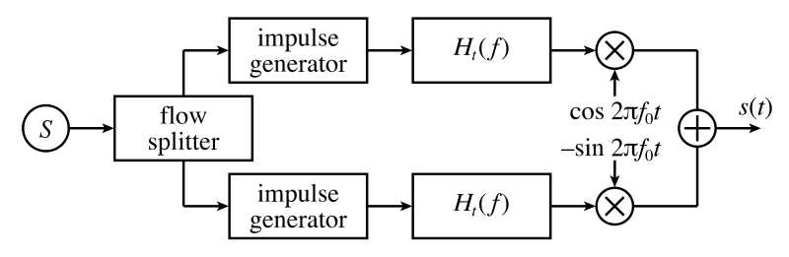

Moving on to the receiver for each type, we see more differences but the general concept remains. To de-modulate a QAM signal we must accurately know the specific frequency of the carrier, since we are using a direct-demodulation technique referred to as ‘Homodyne’ where we do not shift the frequency as for “Heterodyne’ but only the phase. This is achieved through a ‘Phase-Lock-Loop’ that detects the phase shift between our acquired signal and our local oscillator, which ideally is a copy of the same carrier we used to modulate the signal before transmission. We use this phase shift in a feedback loop controlling the local oscillator to synchronize with the carrier envelope of the received signal. Now that our local oscillator is synced with the signal we can do the same process as for the transmitter, we split the signal (without any special considerations like for the transmitter), and ‘mix’ it with the synced local oscillator which is also in quadrature. In doing so we reacquire the original signals that have been modulated, however in addition to higher frequency cosine and sine terms, which generally have twice the frequency of the carrier. This predicable behavior makes it an easy task to filter out the higher order terms using a low-pass filter. For analog, this all that is required since you now have your initial signal. For a digital, however this is not the case, since special consideration is needed in also synchronizing the binary waveform acquired after de-modulation, to the intended initial binary string. This is best achieved by using an easily recognizable pattern of on-off values, which can align where the string starts, and stops, leading and trailing the signal. This, however, has to be done in the transmitter portion right before the binary string is about to be partitioned to be modulated, by prepending and appending the string with the desired pattern. (An ideal receiver diagram is shown below, sourced from Wikipedia)

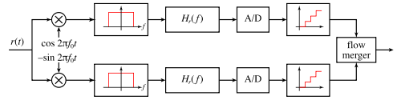

Finally, the hardware portion of the project, the radio transmitter and receiver circuits. Since we are doing the heavy lifting in the software, we only need to construct a power amplifier to drive the transmitting antenna and another voltage + power amplifier following the receiving antenna to generate a sufficiently large signal to be read by the LabView’s DAQ analog input leading to the receiving stage. The general construction for both is an op-amp (such as a LM358, or &741) for the voltage gain and for their feedback properties to properly replicate the signal after the class-b power-amp composed of two ‘paired’ transistors (such as a TIP3055 (PNP), and a TIP42 (NPN)). This is done to minimize irregularities in the output since the transistors conduct in a push-pull manner, meaning that they both do not conduct at the same time, which also causes clipping due to their voltage drops across the base to the emitter, but is eliminated by the feedback from the op-amp. Now the antennas are functioning similar to a RC tank circuit, that are both tuned to the same frequency to achieve resonance coupling. A schematic of the transmitter and receiver is shown on the next page.

Unfortunately, we were not able achieve a working phase-lock-loop which caused our receiver to not properly synchronize our local oscillator used for demodulation for the analog QAM, so we are only able to remove the carrier envelope but not separate the two initial signals from one another. The digital portion fared much worse, as we did not manage to produce a working LabView code to handle the QAM modulation. Additionally we’ve had some issues with the hardware as well, most likely due to our lack of a properly tuned pair of antennas, and the breadboards poor performance for RF prototyping.

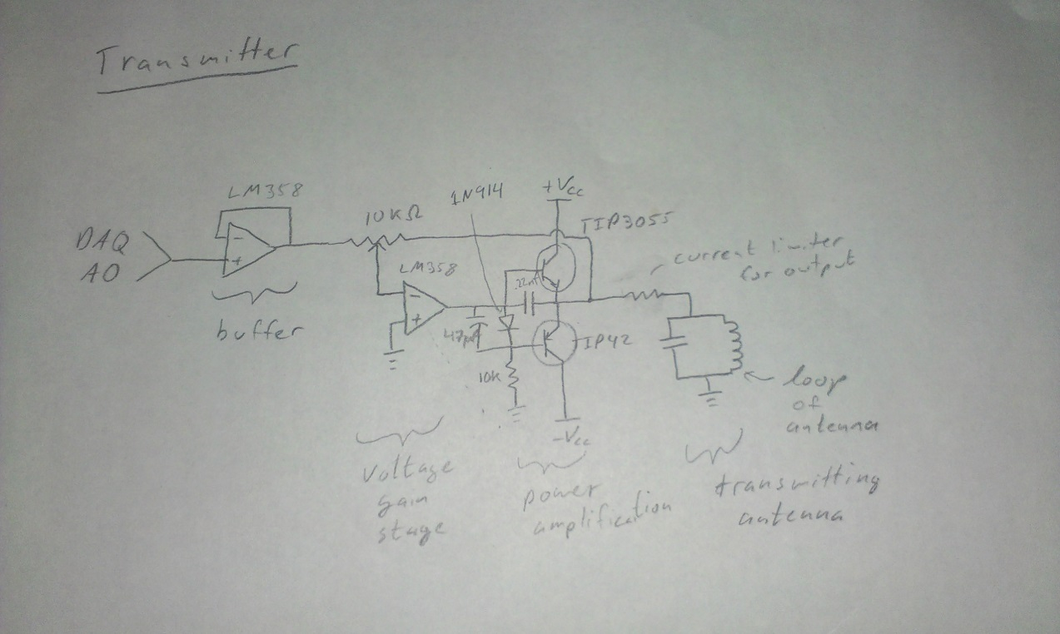

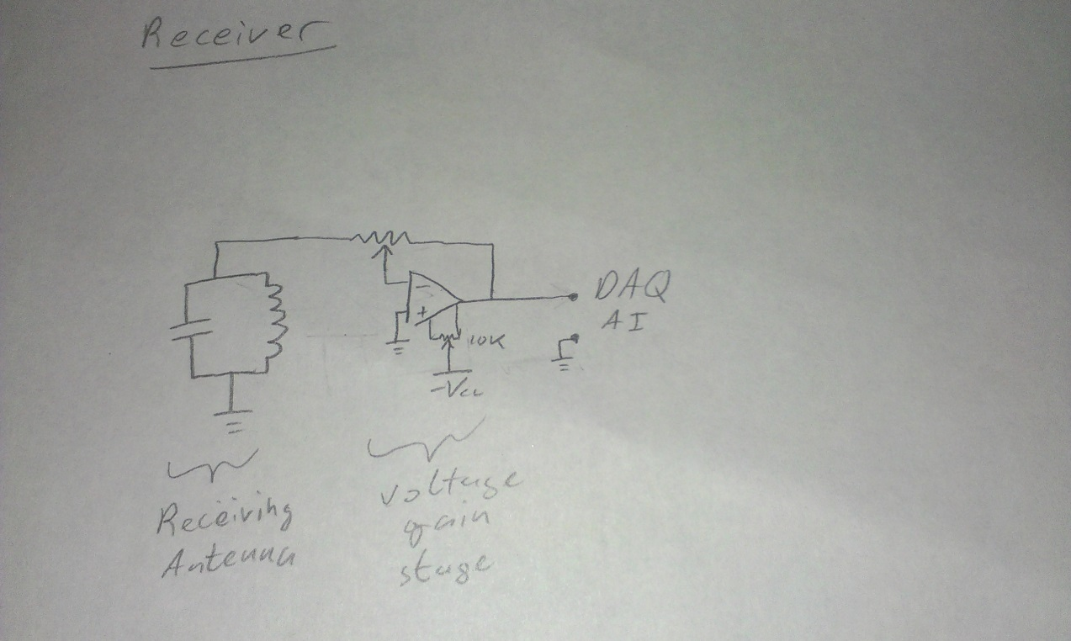

1. System Architecture
   1. Architectural Design

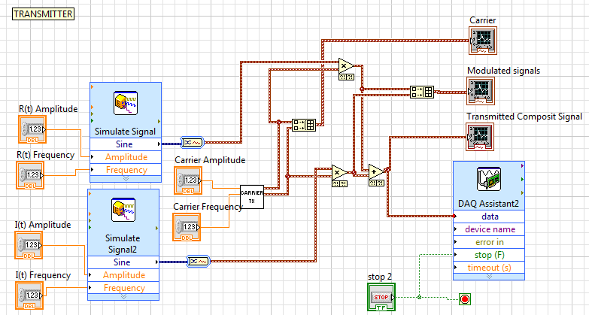

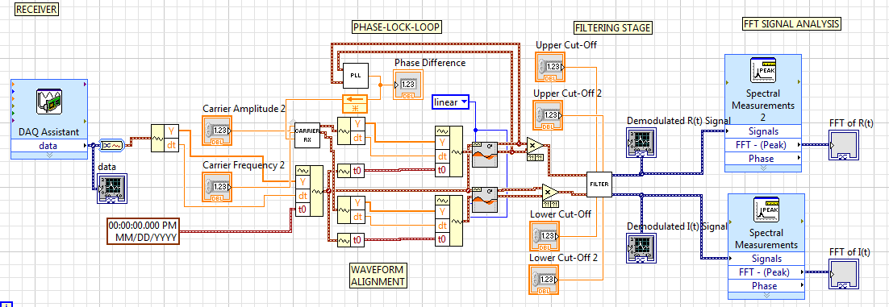

There are two main sections for the analog QAM, a transmitter and receiver. The transmitter uses two simulate signal Express VI, to produce our initial signal. This is then modulated by our carrier sub-VI that produces our required quadrature carrier waveform by appling a Fast Hilbert Transform which gives us a 90 degree phase shift. After modulation is then output to several plots for diagnostics, and a DAQ assistant set up as an analog output.

The receiver receives its input signal from another DAQ assistant which is set up as an analog input. It is then resampled and aligned in order to be mixed with the carrier envelope. Our Phase-Lock-Loop which takes measures the phase difference between the signal and the carrier feeds its result back into the carrier sub-VI to synchronize the two waves, but as already mentioned this did not work out practically. This section is then followed by a filtering stage which utilizes 2 band-pass filters for each signal, to remove the higher order terms produced by the demodulation, and potentially other unwanted lower frequency noise. Afterwards it is displayed in a waveform graph and a FFT for each of the two signals in order to compare them easily to the initial. The radio transmitter and receiver are intended to be attached to their respective DAQ analog in or output, although as mentioned before this did not work as intended, and we substituted it for a direct connection between the in and output.

* 1. Design Rationale

This architecture seems to follow the general scheme of regular radios, although majority of it is virtualized on a computer instead of on hardware. We considered other means of wireless communication, IR or other light-based means mainly. These would simplify the hardware sections immensely however we expect better signal to noise ration from radio in the low frequency to AM bands, however this has proven rather difficult due to our limited knowledge of RF engineering and time constraints. If we where to do this project again, we would omit the radio portion of this project and focus on a simpler single wire connection.

1. Human Interface Design
   1. Overview of User Interface

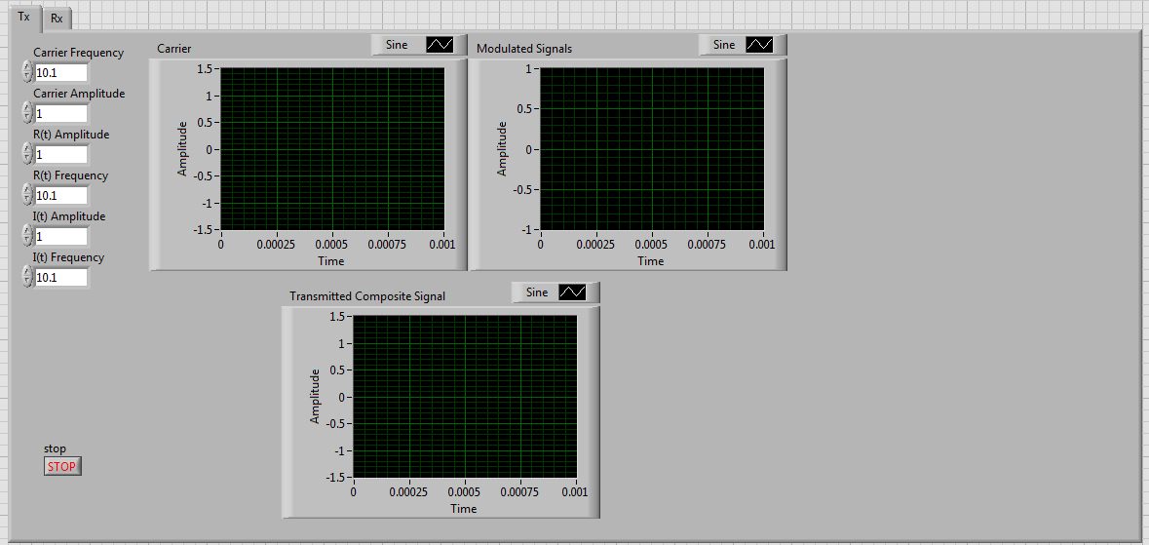

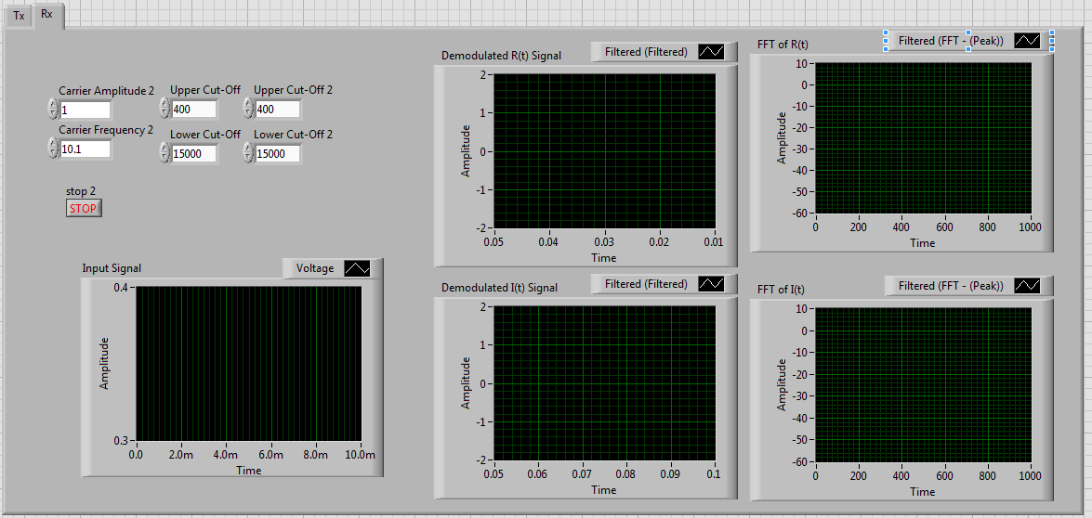

And our Testing environment

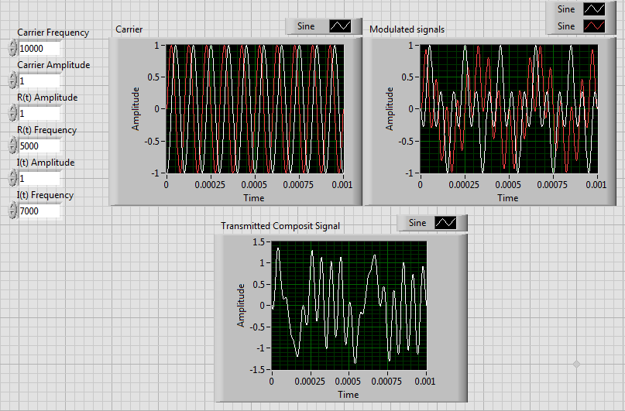

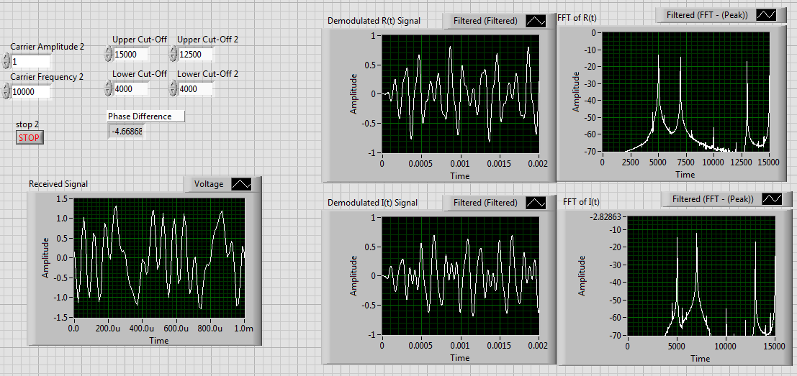

The analog QAM portion of the project gives us the ability to modulate two pure sine waves send them over an analog means to a receiver which then demodulates them. We are able to set our desired carrier frequency and amplitude, in addition to those of the two input signals. For the receiver, we are also able to do the same for the local oscillator used to do the direct demodulation, with addition to setting the filter stage properties. There are also plots which show the transmitted and that of the received signal, the demodulated signals and their respective frequency domain decomposition.